Andrew Baran
Professor Labouseur
Database Management
April 3rd, 2014
Lab 8: Normalization Two

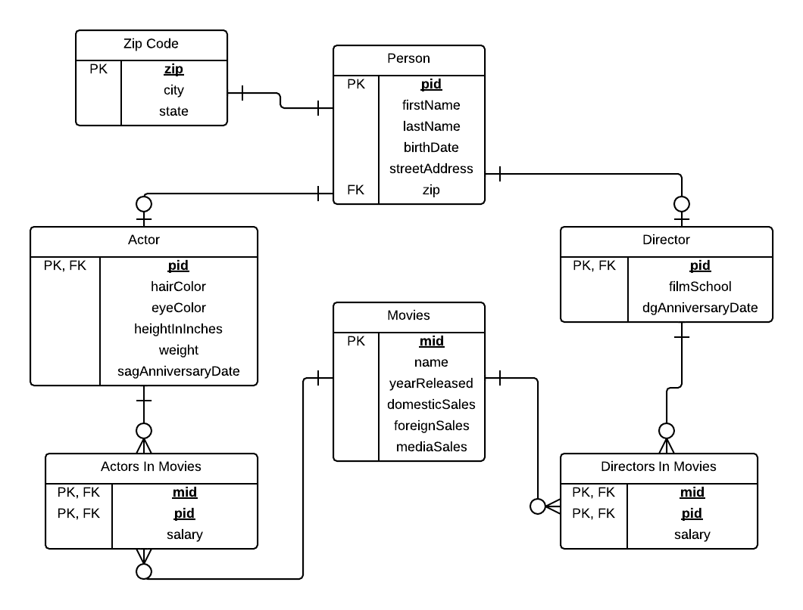
1. ER-Diagram for the constructed Movie database:

4. Functional dependencies for each relation:

Person
pid → firstName, lastName, birthDate, streetAddress, zip

Zip
zip → city, state

Actor
pid → hairColor, eyeColor, heightInInches, weight, sagAnniversaryDate

Director
pid → filmSchool, dgAnniversaryDate

Movies
mid → name, yearReleased, domesticSales, foreignSales, mediaSales

ActorsInMovies
mid pid → salary

DirectorsInMovies
mid pid → salary

5.

select *
from person
where pid in (select pid
from directorsInMovies
where mid in (select mid
from actorsInMovies
where pid in (select pid
from person
where firstName = 'Sean'
and lastName = 'Connery')));

